Administrator
M. Hunzala arshad Student Id : 1704670
Safe carz limited

Content
Abstract 1
Acknowledgement 2
Requirement 3
ScreenShot 4
Task Sheet 8

Abstract
This project, titled “Insurance Website”, is developed to provide a simple and user-friendly platform for users to explore different vehicle insurance plans online. The main objective of this website is to present information about various insurance products from multiple companies in an organized and accessible way.
The website allows users to view insurance plans based on categories such as company name and vehicle type (e.g., two-wheelers and four-wheelers). Each plan includes a brief description along with its base price, helping users make better decisions.
This project is developed using HTML, CSS, and JavaScript to create the structure, design, and interactivity of the website. Additionally, Font Awesome is used to enhance the visual appearance by adding icons.
The website also includes essential sections like a home page, categorized plan listings, and a contact page for user communication. Overall, this project demonstrates the practical implementation of front-end web development skills to build a responsive and informative insurance platform.

Acknowledgement:

I would like to express my sincere gratitude to Ms. Anumta Fareed for her continuous support, guidance, and encouragement throughout the development of my project. Her valuable suggestions and feedback played an important role in the successful completion of my Insurance Website.
I am also thankful to my institute, Aptech Metro Star Gate, for providing me with the opportunity and platform to work on this project titled “Insurance Website”. This project helped me enhance my front-end development skills using HTML, CSS, and JavaScript, and also improved my understanding of designing user-friendly and responsive web interfaces.
I would like to thank my mentor and institute for their constant motivation and support, without which the completion of this project would not have been possible.

Requirements

Requirement Specification:
- Home page should display the website logo and basic details of insurance plans.
- A navigation menu should include introduction, plan categories, and location information.
- Users should be able to filter plans by company (e.g., Zurich Insurance).
- Plans should also be filtered by vehicle type (Four Wheelers, Two Wheelers, etc.).
- Selecting a company should display its available plans.
- Each plan should show a short description and base price.
- A “Contact Us” page should include address and email (clickable to open mail client).

Screenshots:

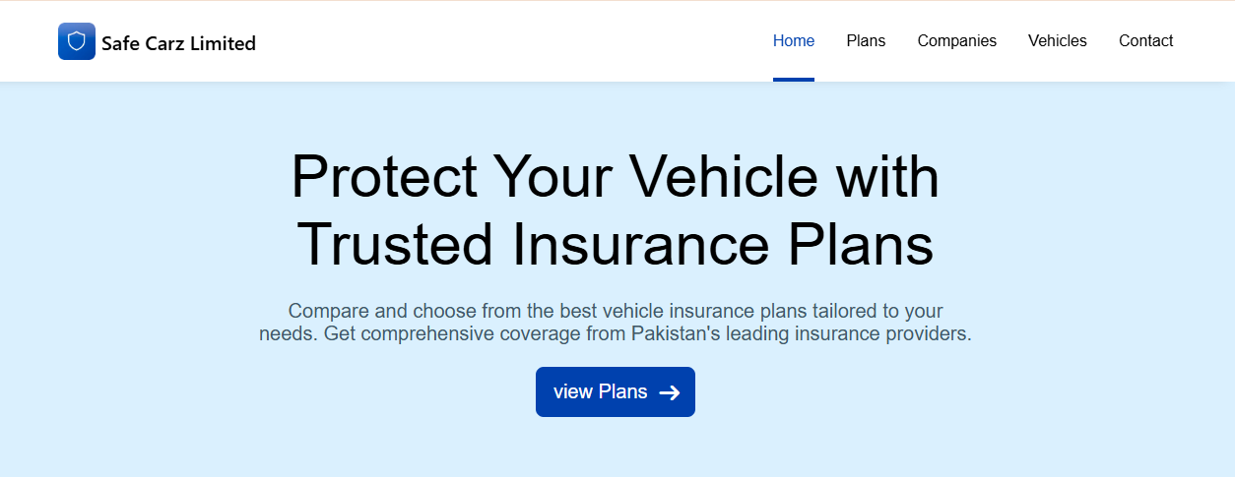

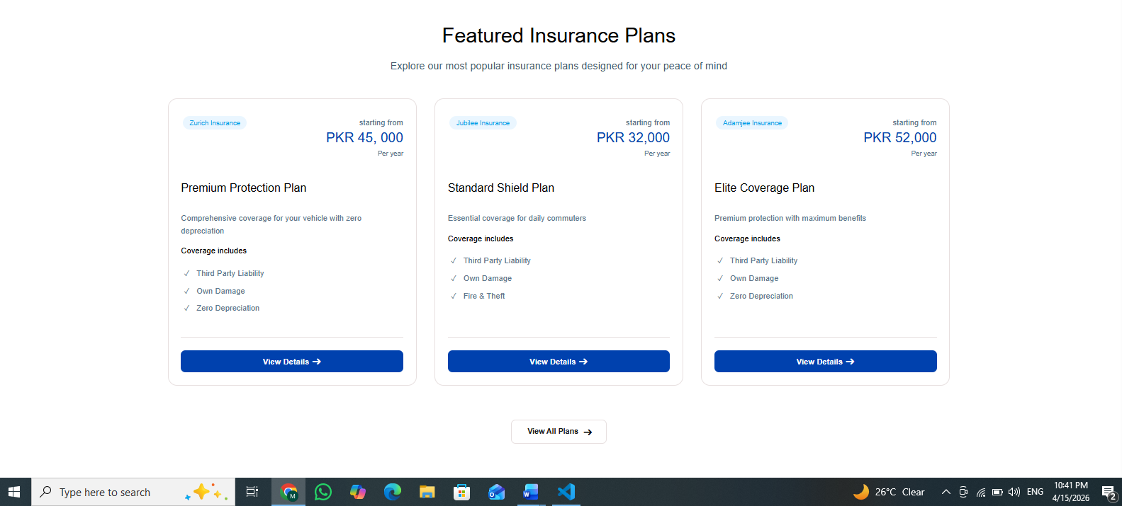

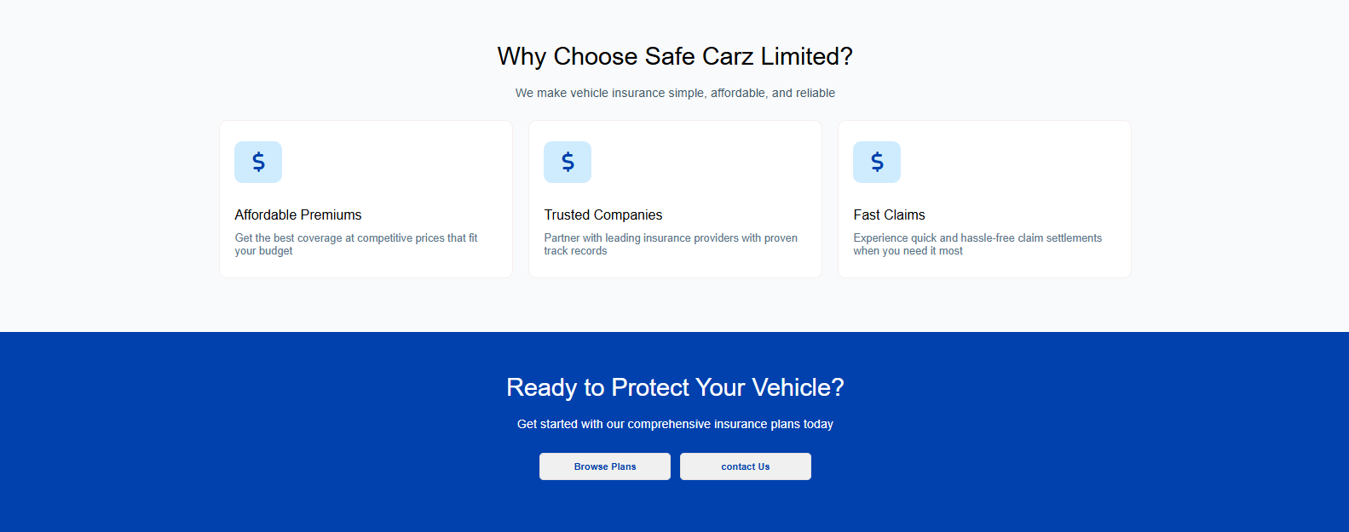


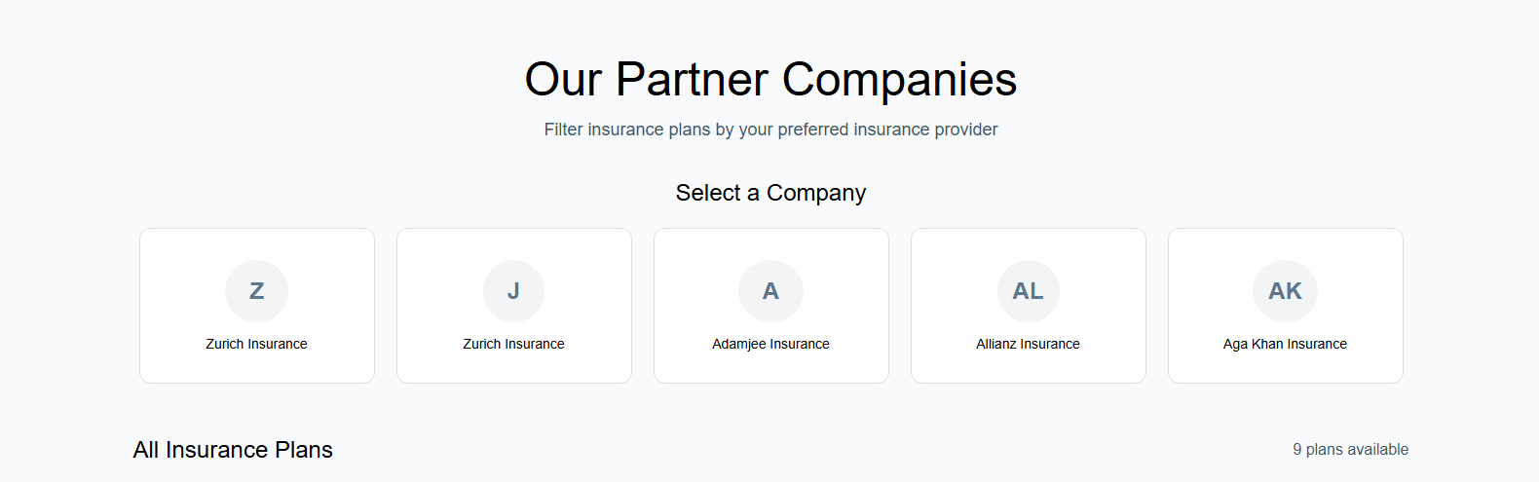

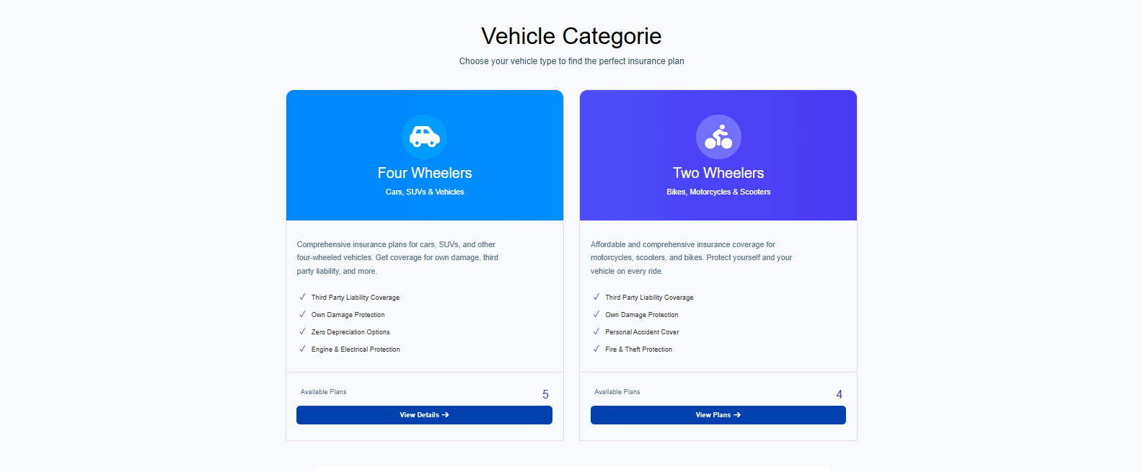


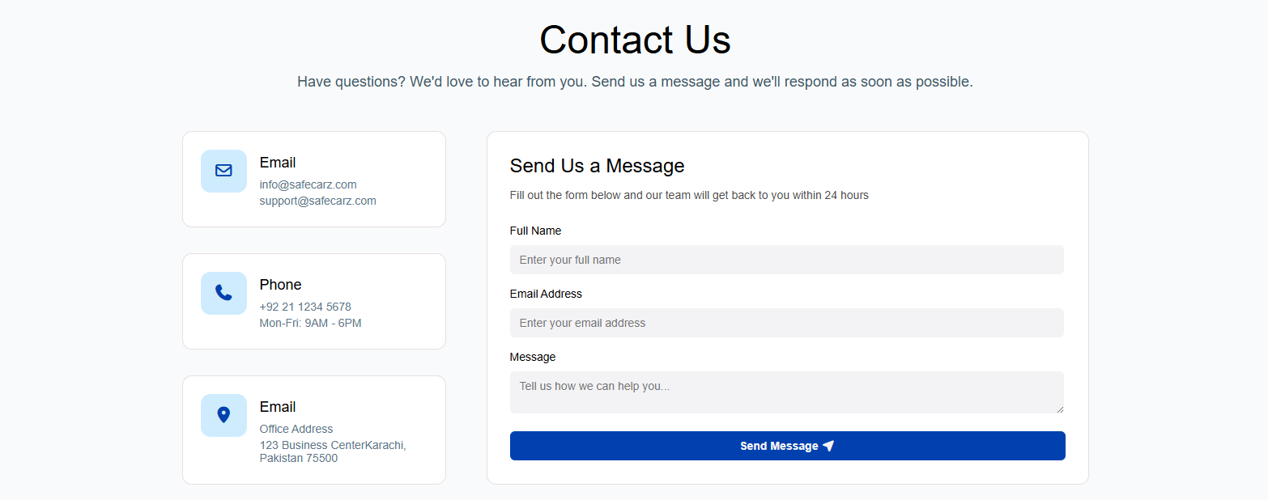
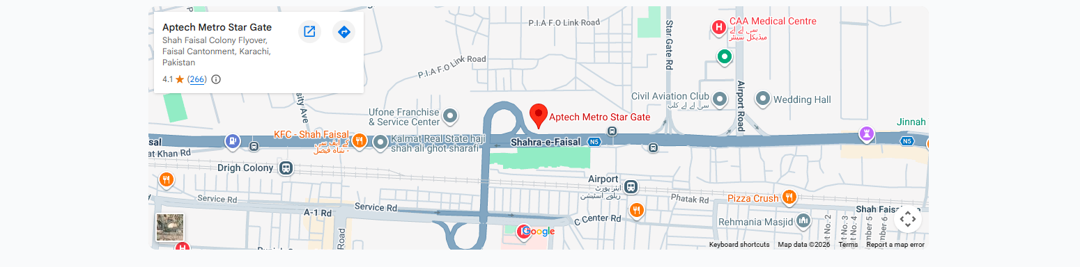
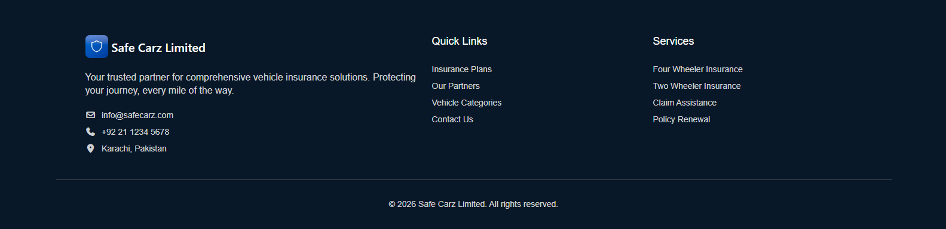

Task Sheet:

Task | Name | Days
Home page | M. Hunzala | 07
Plan page | M. Hunzala | 03
Companies page | M. Hunzala | 03
Vehicle Page | M. Hunzala | 03
Contact page | S.UmmUlBaneen | 05

Thank You

